Qo class

Besteffort class

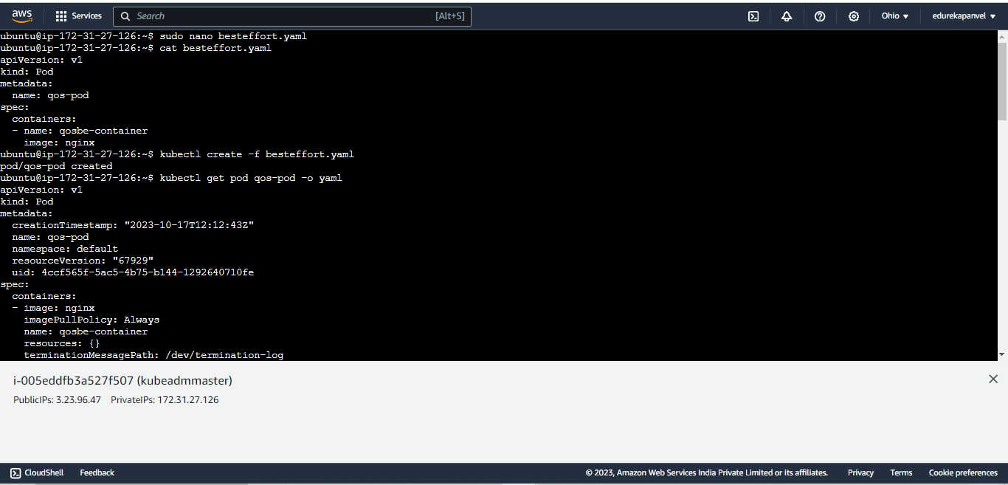

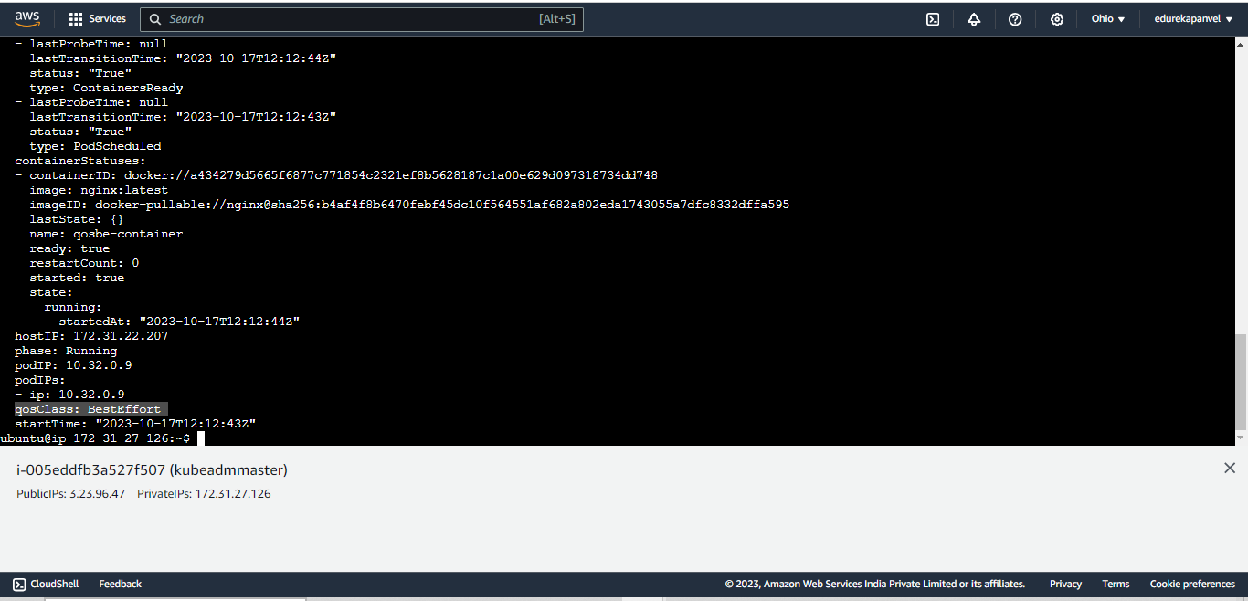

Burstable class

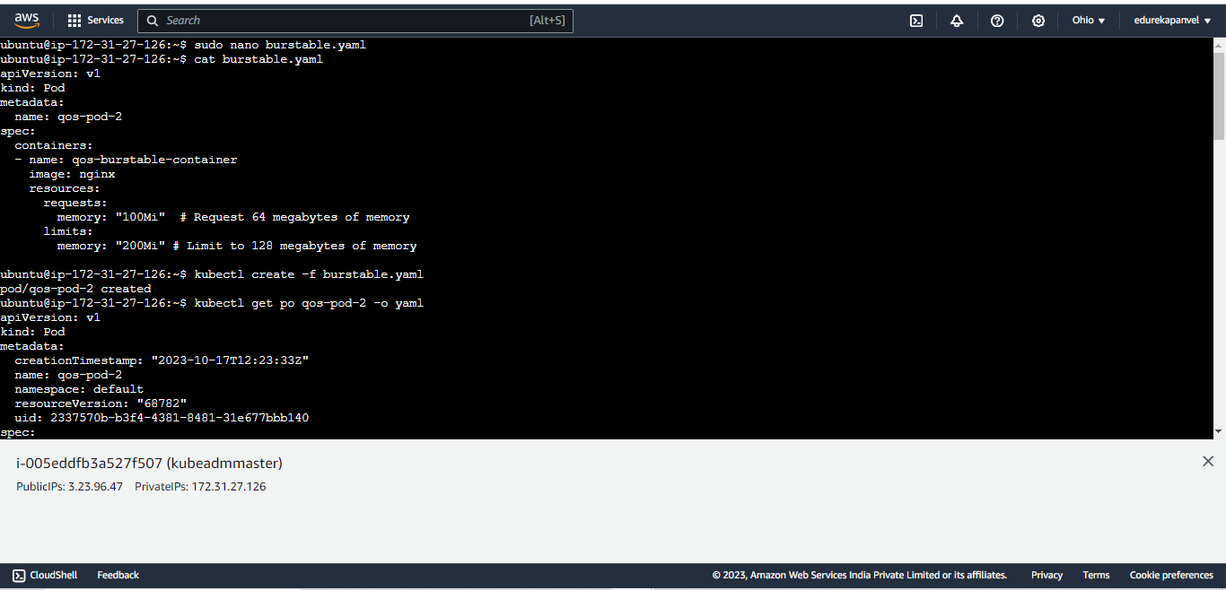

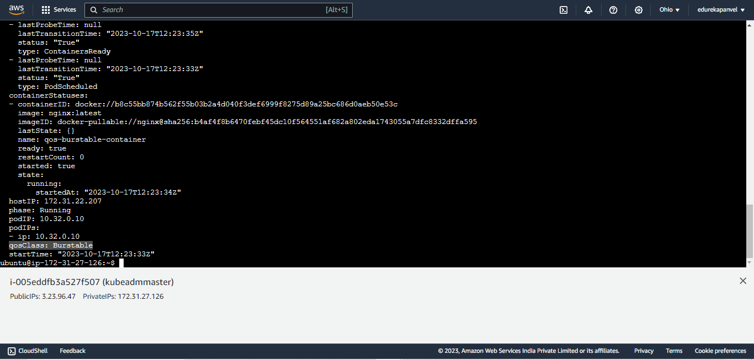

Guarantedd class

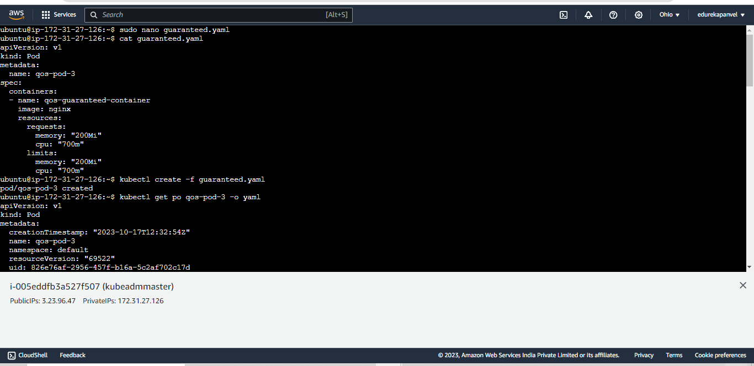

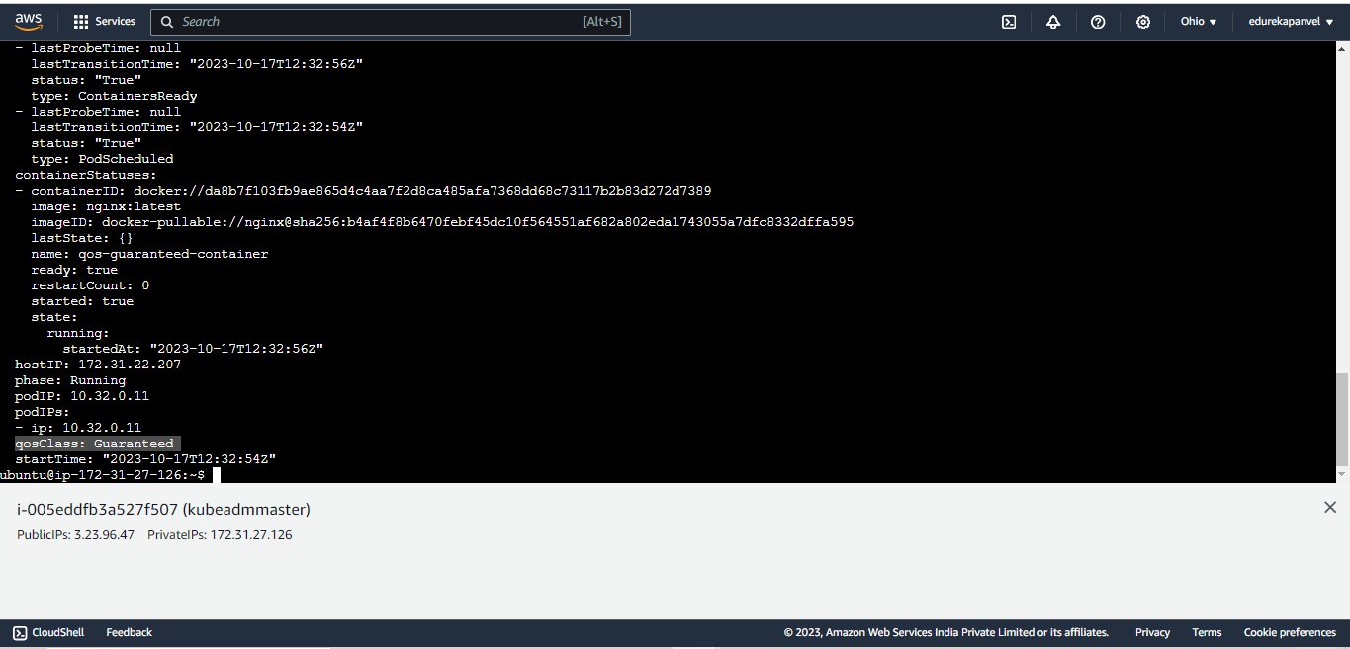

Lu2

**Taints and tolerations**

**Kubectl describe nodes master**

**(to check nodes are taint or not )**

**So thata on master by default we cant create any pod because master node is tainted**

**Kubectl describe nodes worker**

**( so on the worker node thaer are not taint so that why wecan create pod to into int )**

**Kubectl describe nodes | grep -i taints**

**Now how to taints my worker node**

**Kubectl taint node worker app=webserver:NoSchedule**

**(for that we have to define key values & effect )**

**Kubectl describe nodes | grep -i taints**

**Kubectl run testpodnew --image=nginx**

**(here pod is creted but it is not running )**

**Watch kubectl get po**

**Kubectl describe get po**

**( just check for why pod is not running )**

**To crete pod on tainted node we can also**

**remove the taint**

**kubectl taint nodes worker app:Noschedule-**

**( kust give key and effect and mius sign )**

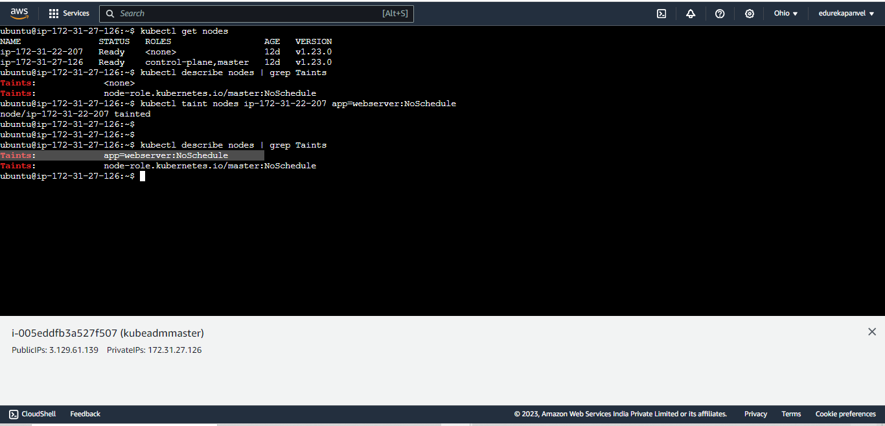

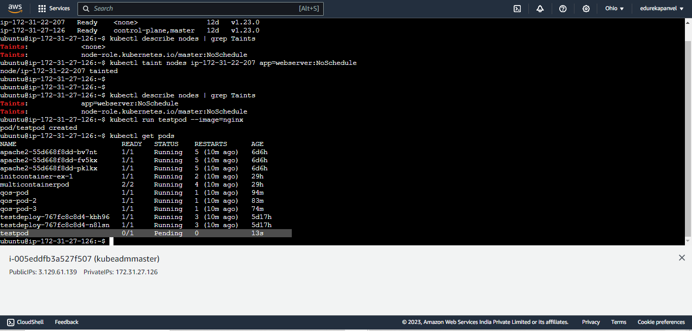

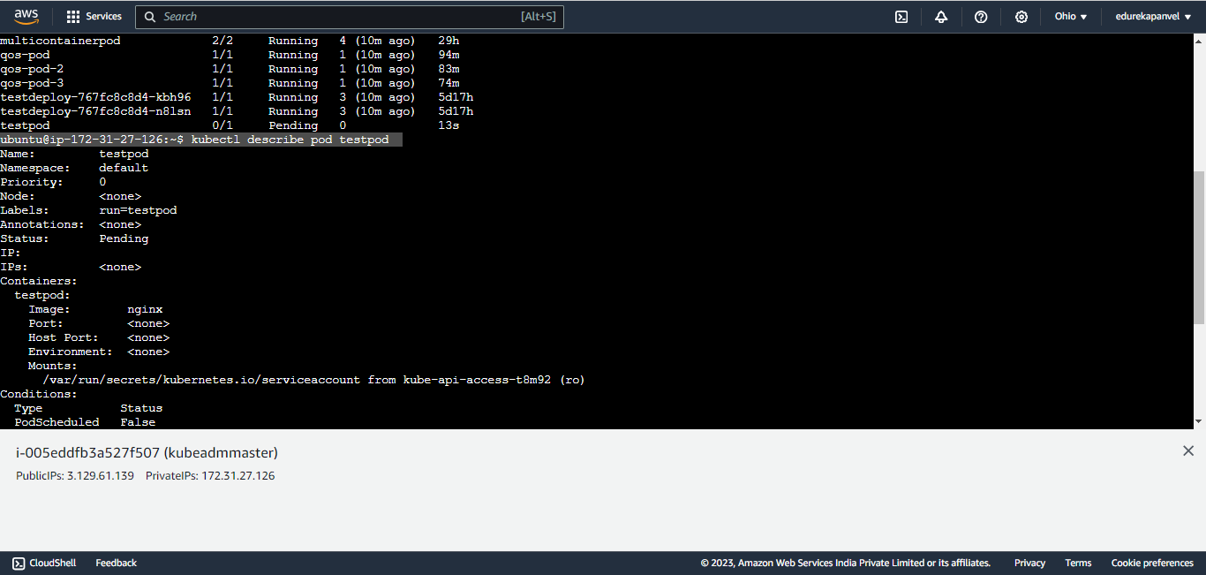

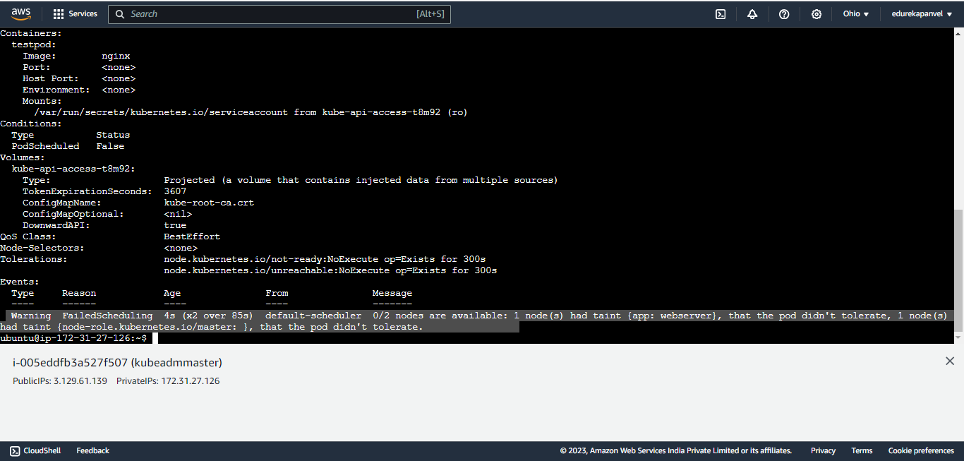

How to create a pod on a tainted node using toleration?

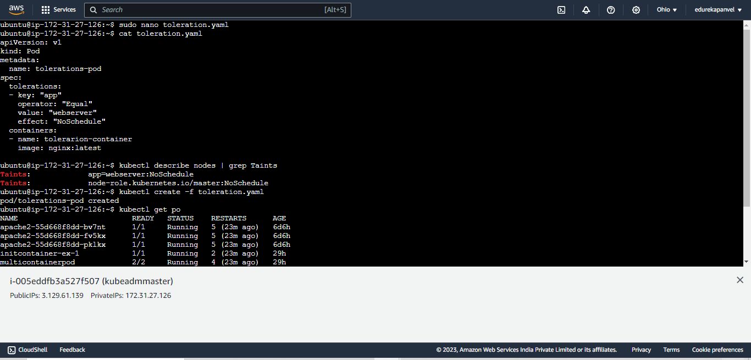

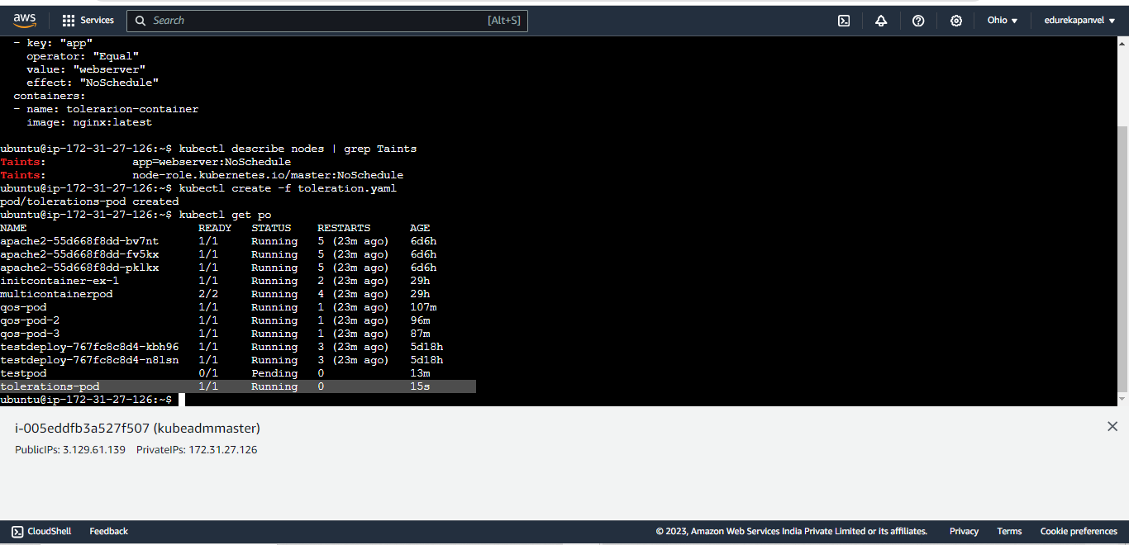

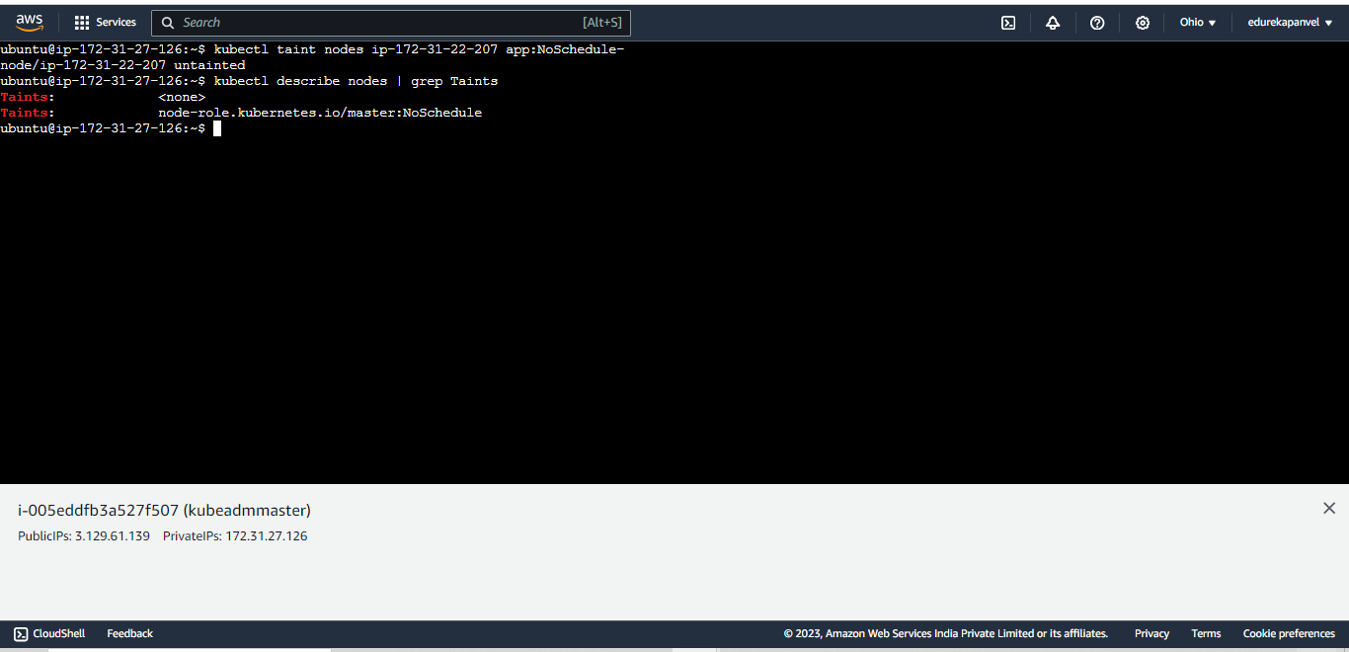

**Or other way to create po on tainted node you can create toleration pod**

**Using a yaml file**

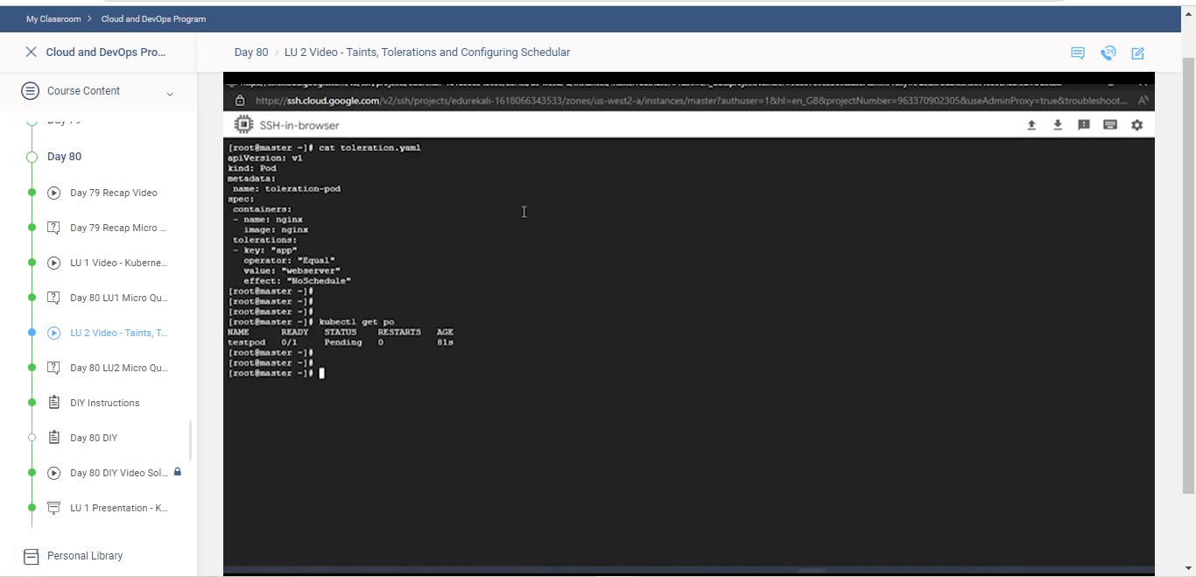

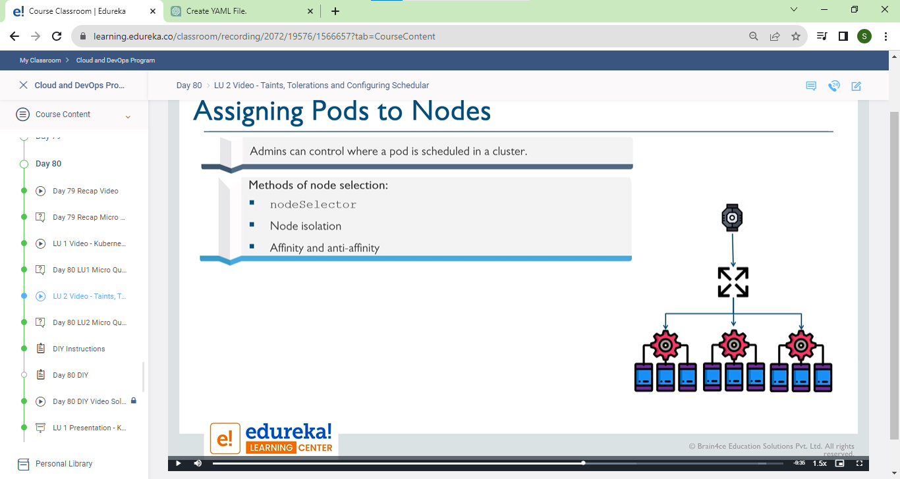

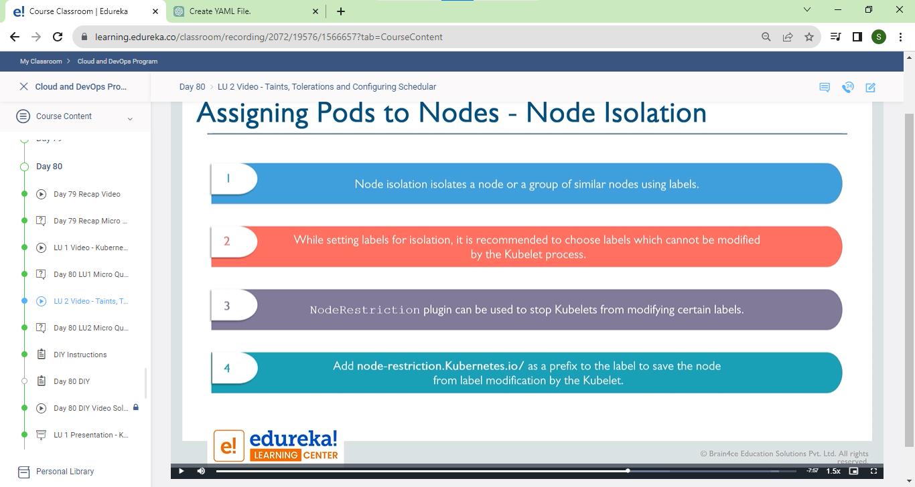

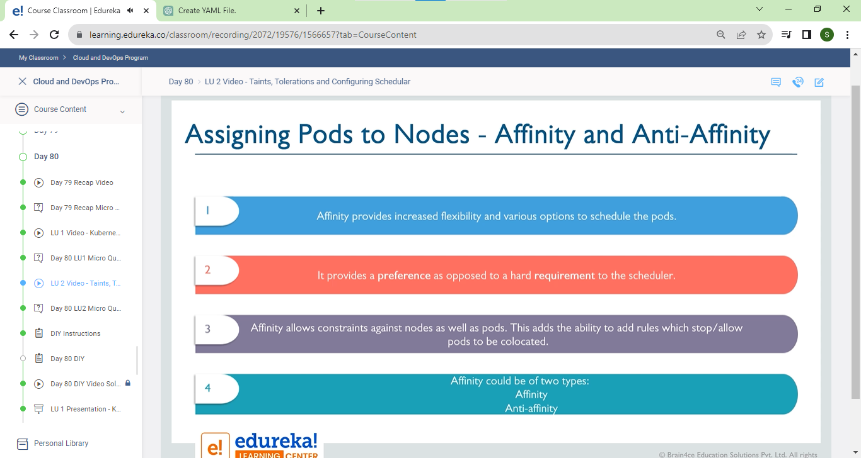

**\*#### Manual scheduling**

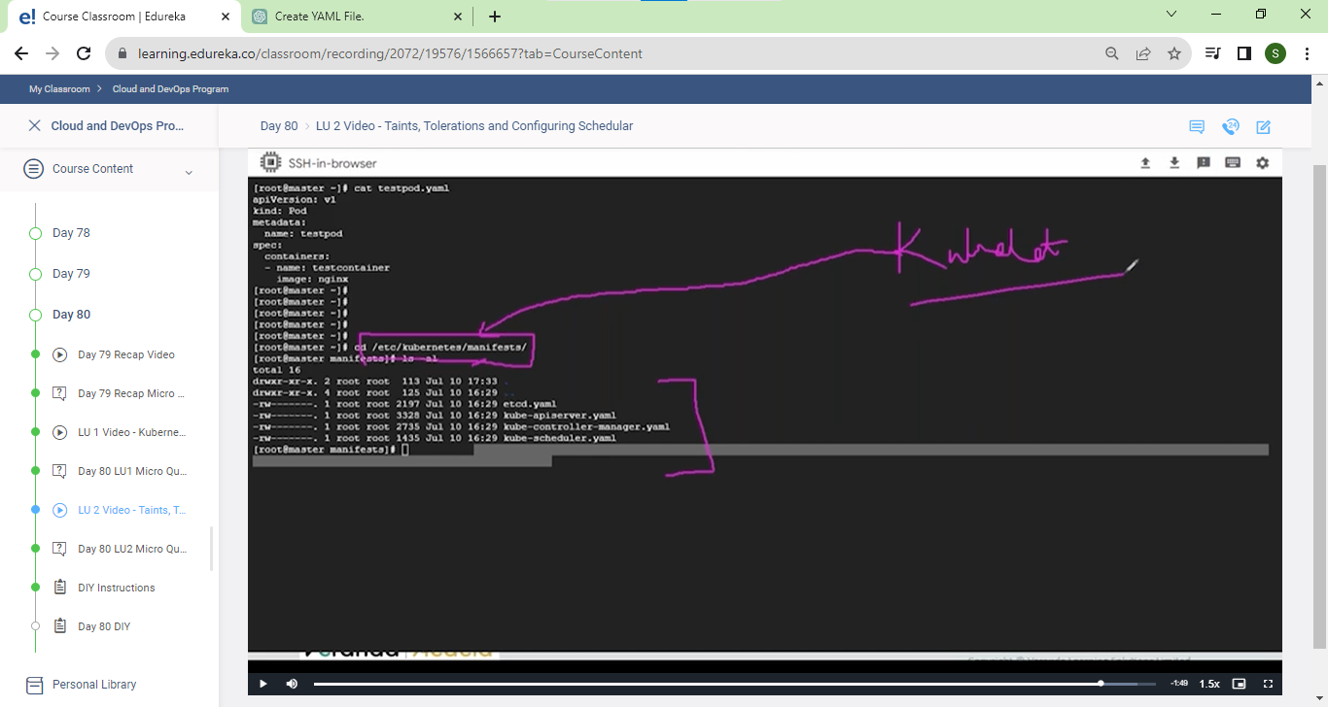

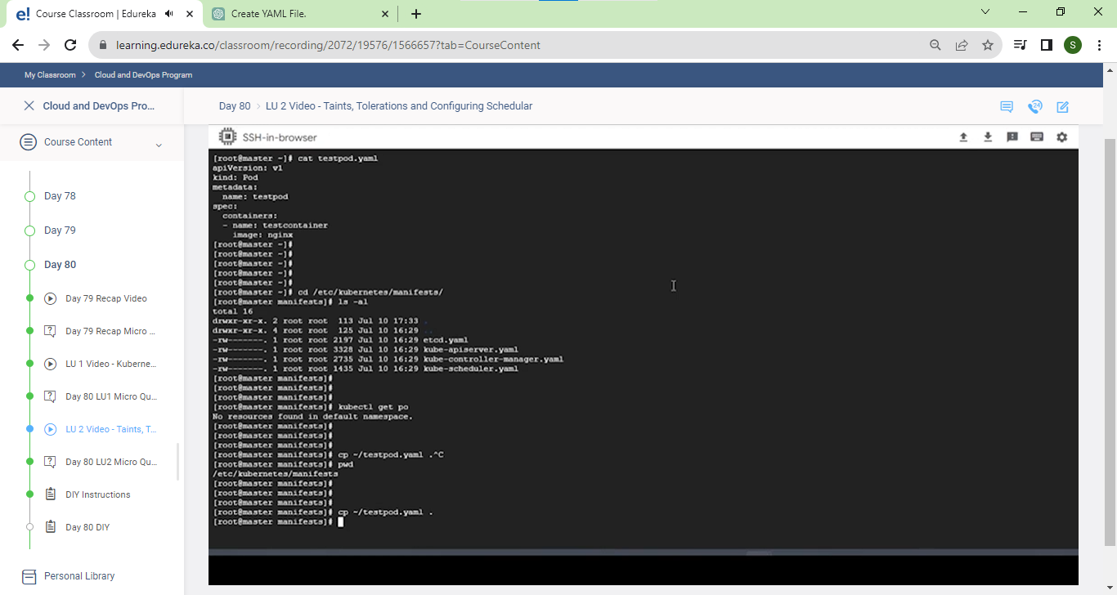

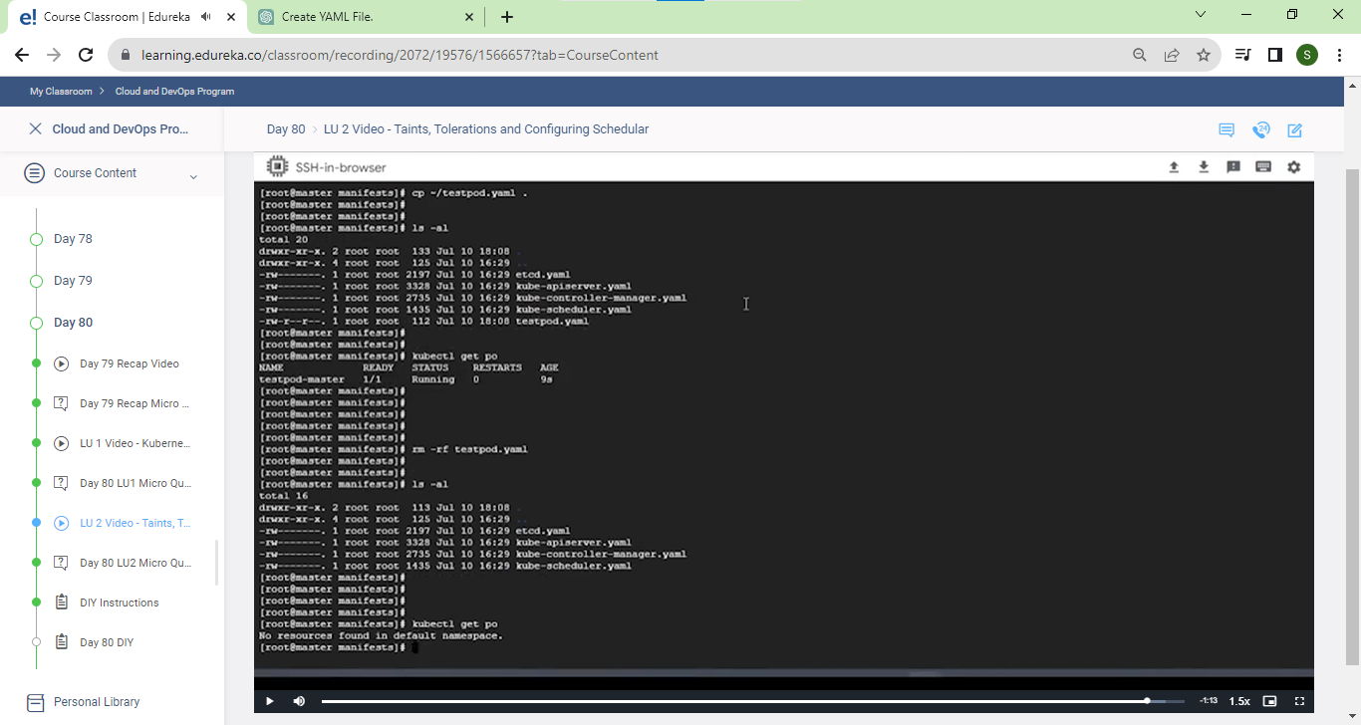

**We can see here kkybectk create –f without running tis command we can crete pod and running also sucsfully**

**Bcz kubectl is constantly moniotor yaml fille if any yaml is there it can exexcute it**